What is Hypothesis Testing?
Hypothesis testing helps in data analysis by providing a way to make inferences about a population based on a sample of data. It allows analysts to make decisions about whether to accept or reject a given assumption or hypothesis about the population based on the evidence provided by the sample data.
For example, hypothesis testing can be used to determine whether a sample mean is significantly different from a hypothesized population mean or whether a sample proportion is significantly different from a hypothesized population proportion. This information can be used to make decisions about whether to accept or reject a given assumption or hypothesis about the population. In statistical analysis, hypothesis testing is used to make inferences about a population based on a sample of data.
The actual test begins by considering two hypotheses. They are called the null hypothesis and the alternative hypothesis. These hypotheses contain opposing viewpoints.
H0 : The null hypothesis: It is a statement of no difference between the variables—they are not related. This can often be considered the status quo and as a result if you cannot accept the null it requires some action.
Ha : The alternative hypothesis: It is a claim about the population that is contradictory to H0 and what we conclude when we reject H0 . This is usually what the researcher is trying to prove.
After you have determined which hypothesis the sample supports, you make a decision. There are two options for a decision. They are "reject H0 " if the sample information favors the alternative
hypothesis or "do not reject H0 " or "decline to reject H0 " if the sample information is insufficient to reject the null hypothesis.

What is a One Sample T Test?
A one sample t-test determines whether or not the sample mean is statistically different (statistically significant) from a population mean.
While significance tests for population proportions are based on z-scores and the normal distribution, hypothesis testing for population means depends on whether or not the population standard deviation is known or unknown.
For a one sample t test, we compare a test variable against a test value. And depending on whether or not we know the population standard deviation will determine what type of test variable we calculate.

How to Calculate a Test Statistic

Standard Deviation Known
If the population standard deviation is known, then our significance test will follow a z-value.
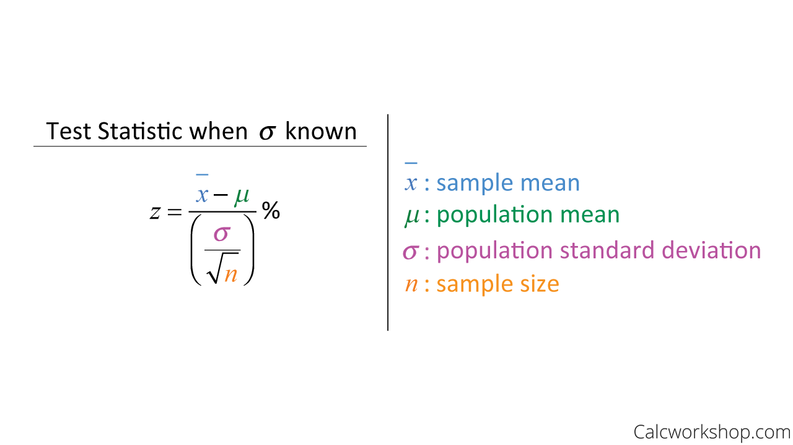

Standard Deviation Unknown
If the population standard deviation is unknown, we will use a sample standard deviation that will be close enough to the unknown population standard deviation. But this will also cause us to have to use a t-distribution instead of a normal distribution
the t-distribution has an additional parameter representing the degrees of freedom or the number of observations that can be chosen freely.
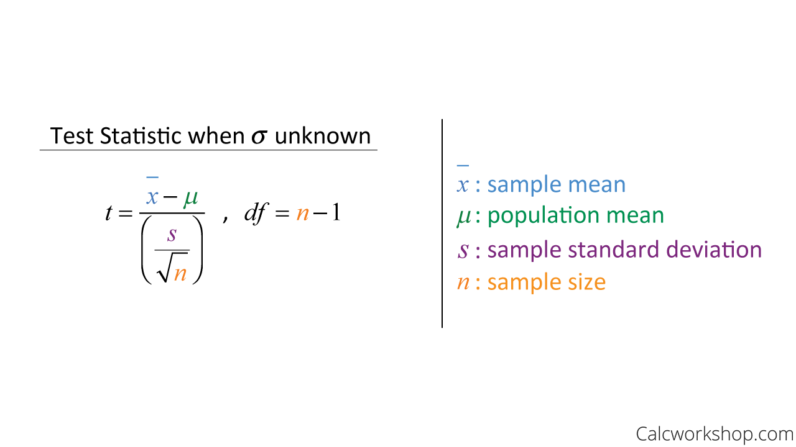

Example Question
For example, imagine a company wants to test the claim that their batteries last more than 40 hours. Using a simple random sample of 15 batteries yielded a mean of 44.9 hours, with a standard deviation of 8.9 hours. Test this claim using a significance level of 0.05.
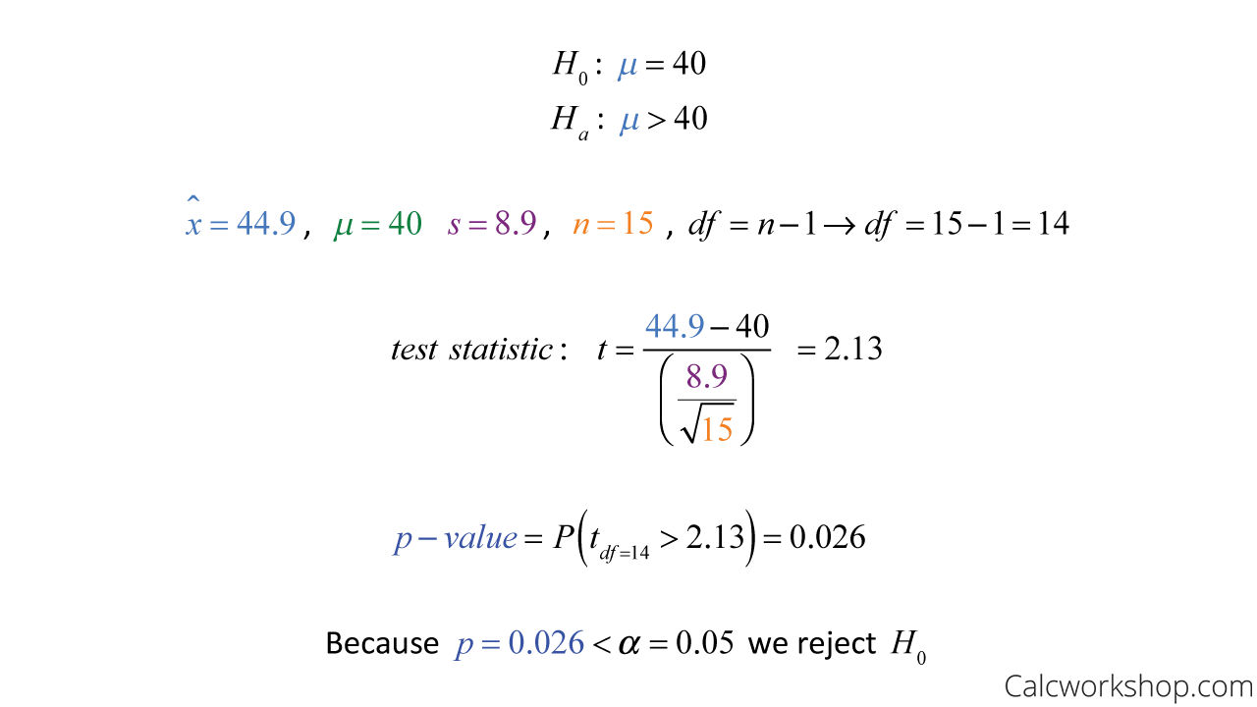
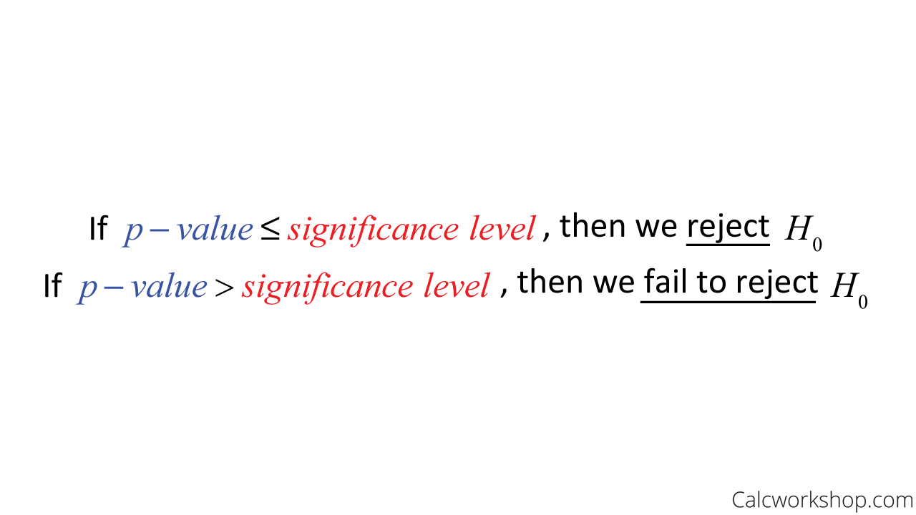

One Sample Hypothesis Testing Example: One Tailed Z Test
A principal at a certain school claims that the students in his school are above average intelligence. A random sample of thirty students IQ scores have a mean score of 112.5. Is there sufficient evidence to support the principal’s claim? The mean population IQ is 100 with a standard deviation of 15.
Step 1: State the Null hypothesis. The accepted fact is that the population mean is 100, so: H₀: μ = 100.
Step 2: State the Alternate Hypothesis. The claim is that the students have above average IQ scores, so
H₁: μ > 100.
The fact that we are looking for scores “greater than” a certain point means that this is a one-tailed test.
Step 3: Draw a picture to help you visualize the problem.
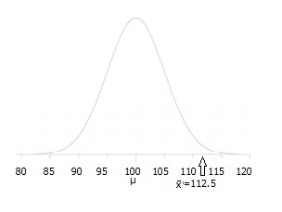
Step 4: State the alpha level. If you aren’t given an alpha level, use 5% (0.05).
Step 5: Find the rejection region area (given by your alpha level above) from the z-table. An area of .05 is equal to a z-score of 1.645.
Step 6: Find the test statistic using this formula: 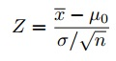
For this set of data: z= (112.5 – 100) / (15/√30) = 4.56
Step 6: If Step 6 is greater than Step 5, reject the null hypothesis. If it’s less than Step 5, you cannot reject the null hypothesis. In this case, it is more (4.56 > 1.645), so you can reject the null.

One Sample Hypothesis Testing Examples: #3
Blood glucose levels for obese patients have a mean of 100 with a standard deviation of 15. A researcher thinks that a diet high in raw cornstarch will have a positive or negative effect on blood glucose levels. A sample of 30 patients who have tried the raw cornstarch diet have a mean glucose level of 140. Test the hypothesis that the raw cornstarch had an effect.
Step 1: State the null hypothesis: H₀:μ=100
Step 2: State the alternate hypothesis: H₁:≠100
Step 3: State your alpha level. We’ll use 0.05 for this example. As this is a two-tailed test, split the alpha into two.
0.05/2=0.025
Step 4: Find the z-score associated with your alpha level. You’re looking for the area in one tail only. A z-score for 0.75(1-0.025=0.975) is 1.96. As this is a two-tailed test, you would also be considering the left tail (z = 1.96)
Step 5: Find the test statistic using this formula:
z = (140 – 100) / (15/√30) = 14.60.
Step 6: If Step 5 is less than -1.96 or greater than 1.96 (Step 3), reject the null hypothesis. In this case, it is greater, so you can reject the null.

